Program Navigator Approver Directions

Login to Program Navigator
Program Navigator is the software. Login: https://www.programnavigator.minnstate.edu
- You must use Mozilla Firefox and be on a campus computer or in a VPN in order to access Program Navigator.
- Use your StarID for Login

Tips for Creating Accessible Documents
- Select the view in your My Folders
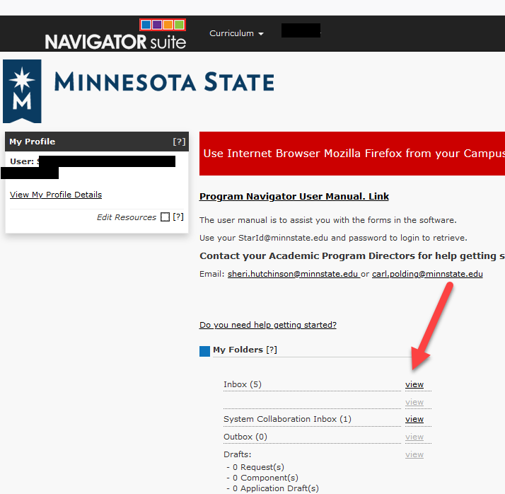

- Select the “envelope” Request number
- You will see the title, who submitted, date submitted and the workflow step will show CAO. Some areas show the SAO change, but just in case!

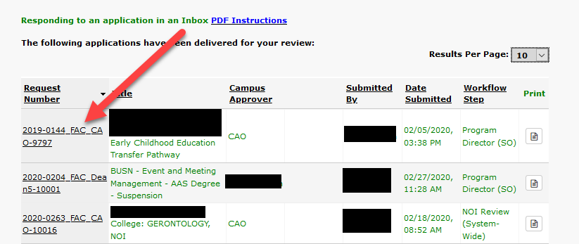

Next, you will enter the envelope. You may see notes or simply an approve from the Initiator, Dean, Curriculum Chair, CAO/SAO, or President, depending upon how many steps you included in your workflow, or just a comment from the Initiator if you have only two-steps in your workflow.

The envelope shows a checklist that is optional for a campus to complete, but gives approvers a “checklist” of items to attach to the program application. This is a good list for the final approver to use as a guide when reviewing.
Academic Council Meeting Minutes OR Curriculum Committee Minutes per institutions

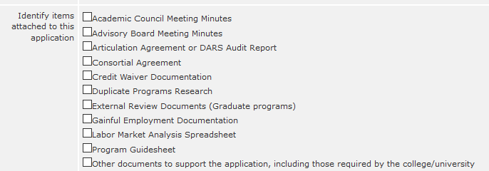

Entering the Application to Review
- Select the program Code
- Read any comments, as appropriate

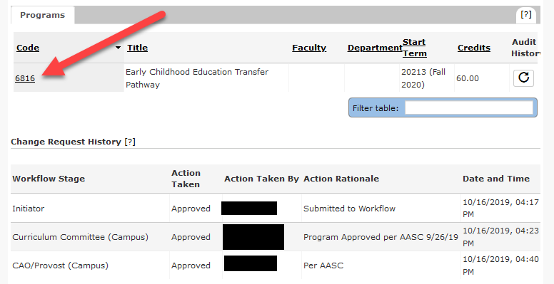

Review the application, as appropriate
- Select the Tabs across the top (Locations, CIP Codes, Emphasis, and Attachments)
- Should anything be missing from the attachments, the envelope may be relegated back to the initiator
- Only a maximum of 10 documents will be viewable in Program Navigator. If you see a second page on the attachments page, no one will be able to view additional documents.

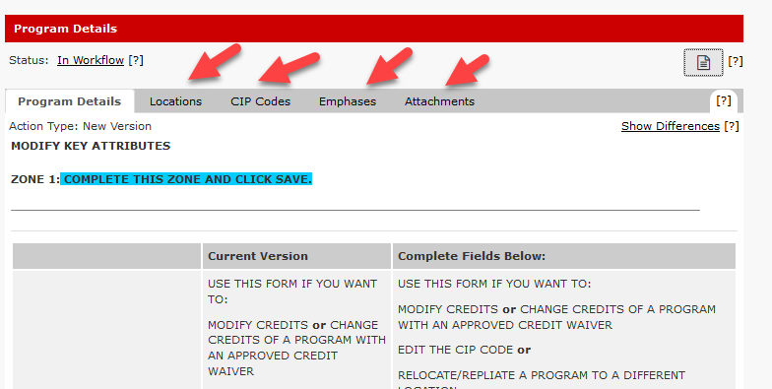

When you have finished your review:
- Select the Previous Page from the Details tab to return to the envelope
- Scroll to the bottom of the envelope to the Workflow Management
- Select the dropdown Workflow Action
- Select either Approve Request, Send to Prior Stage or Relegate to Initiator
  - If you notice something is missing from the checklist, you are able to relegate the application to the Initiator to add the missing items. You also may email the missing items to an Academic Program Director to attach to save time.
- Enter any comments in the Action Rationale that you would like to state to the Academic Program Director about the program
- Select Submit

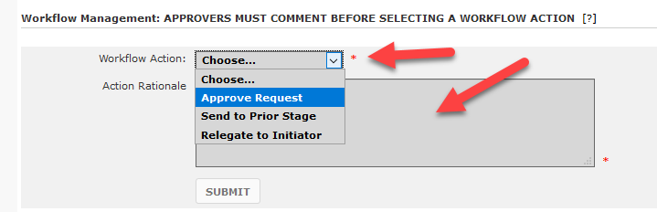

If you need assistance, contact an Academic Program Director:
- Sheri Hutchinson, Sheri.Hutchinson@minnstate.edu,

